**Name Manjinder Singh**

**ID**

**Title: Booking System**

# Section 1- Project planning and design

## Task 1 - Identify the problem

Indentified problem: they want to provide online booking for their customer to increase their experience and grow more.

While talking to Lovepreet Singh I indentify he is losing many customers due to no online booking at his store as all competitors are providing this faculty to their customers and now Lovepreet also want the same but with more security and features as their competitors giving.

Moreover I discussed that this website will be open to access to all for checking tickets and booking them so we need put very good security so that no one could hack data or do anything with the website and it is chance that more customers will open this website from mobile so this will be purely Responsive

## Task 2 -

### Scope of Work-

Provide a Website that can book the tickets and handle a record of customers and customer need to register to the website and then login to use to website.

### The features

As most of the customer base of watching movie is online so they prefer to search online and that’s why client’s major requirement is to provide SEO good site so that it could appear at the top of search results and client get this customer and more over it will provide all the features like Login and register and Booking a ticket.

### Functional Requirements

* Navbar on Top in working condition
* Every Link should Work
* Desired Result should open
* Prevent Crashing the software

### Non-functional requirements

* Very good SEO Work
* Fully Responsive up to any device
* Page Load Quick

## Time- Total projected time

Maximum time I got to complete this task 19 days but with strategies of project management I completed all task of this project in 15 days

|  |  |
| --- | --- |
| Task | Days |
| Feasibility Study | 2 |
| Planning | 2 |
| Requirements | 2 |
| Designing Code | 4 |
| Development Code | 4 |
| Unit testing | 1 |
| Total | 15 |

### Cost –

Total Cost in build this project: $2700

|  |  |  |  |  |  |
| --- | --- | --- | --- | --- | --- |
| Total Hours | Per Hour | Calculation | Total | Discount | Grand Total |
| 100 | 29 | $ 29 * 100 | $ 2900 | $ 200 | $ 2700 |

Referring above

|  |  |
| --- | --- |
| Planning | $ 200 |
| Requirement | $ 300 |
| Designing | $ 1000 |
| Development | $ 1000 |
| Testing | $ 400 |

### Project management-

5 Phases of project management help me lot in completing this project and this is the reason earlier mentioned also I completed this project 3 days before deadline as done planning first about what to and discussed with client and then Executed the coding and show project performance step by step to client.

I followed all the above steps of PM and also one methodology i.e. Waterfall methodology expanded below:

Waterfall Model is a sequential model that divides software development into pre-defined phases. Each phase must be completed before the next phase can begin with no overlap between the phases. Each phase is designed for performing specific activity during the SDLC phase. It was introduced in 1970 by Winston Royce.

With the above techniques I completed by project by Finalizing and optimizing the code

### Risk management- Using

Risk Management: A computer code project may be derailed due to an unusually high level of risk. It's vital to categorise hazards into distinct categories in order to be able to consistently identify the necessary dangers that could affect a computer code project.

Project Hazards:

Various types of financial funds, timelines, human, resource, and customer-related concerns are all examples of project hazards. Schedule slippage is a critical project risk. It's extremely difficult to monitor and manage a computer code project because it's intangible.

Technical Hazards:

Potential style, implementation, interface, testing, and maintenance concerns are all technical hazards.

## Gantt Chart

## 

Week 1

Week 3

Week 2

Tasks

Planning & Study

Requirement

Design & Develop

Finalization

## Task 3 - Design mockups

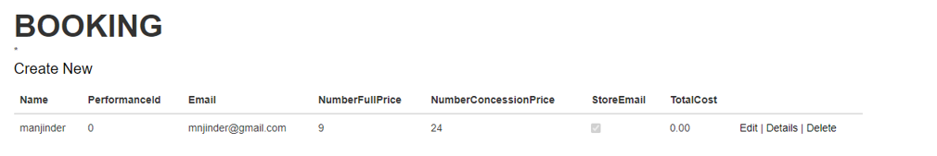

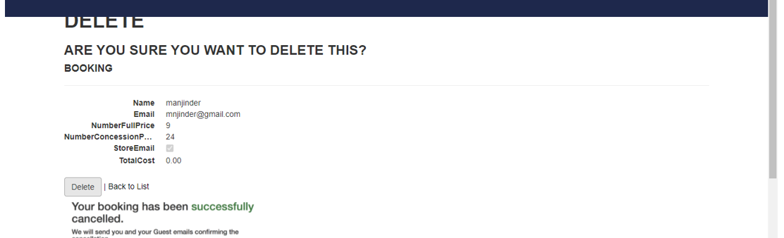

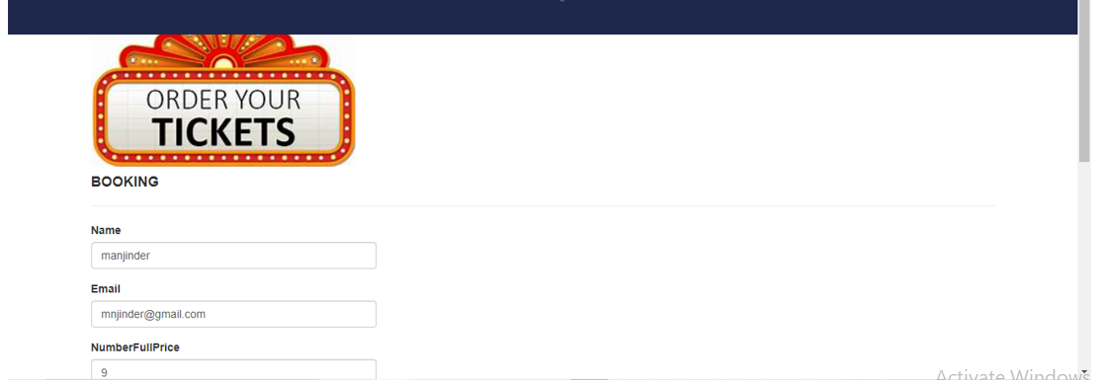

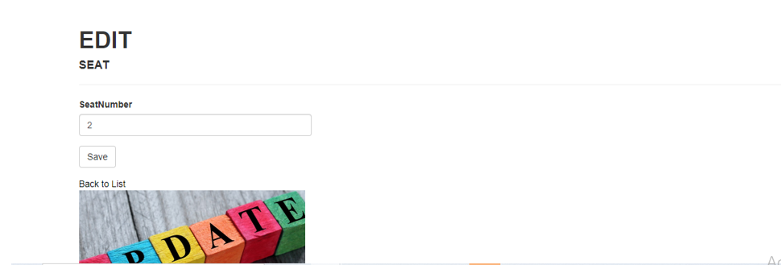

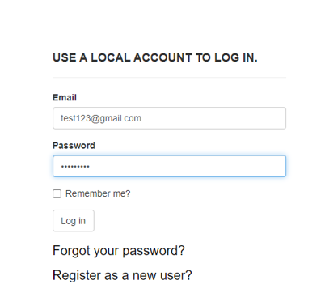

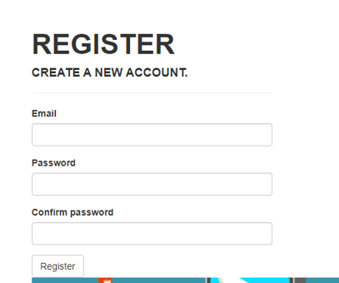

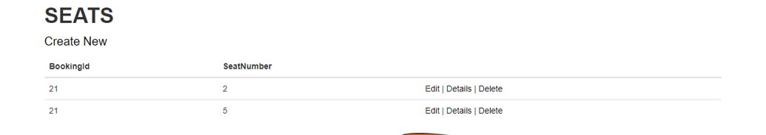

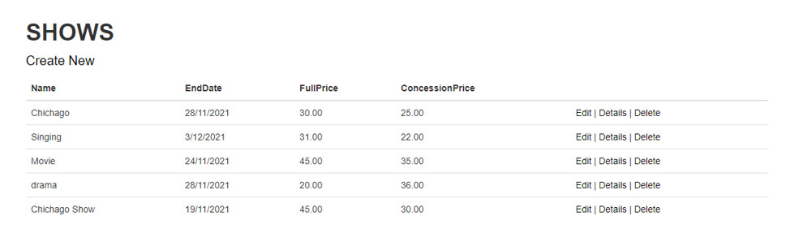

# Section 2 – Project development

## Task 4 – Coding

Is In Project Folder

## Task 5- usability testing

Participant 1: Male, 22 Student

Participant 2: Female, 21 Student

Participant 3: Male, 23 Student

Task: Login Page

Task 2: Registration Page

Task 3: Booking Movie

Task 4 : Add Show

|  |  |  |  |  |
| --- | --- | --- | --- | --- |
|  | Task1 | Task 2 | Task 3 | Task 4 |
| Participant 1 | Done with no issues | Registered | Need more Confirmation line Email,SMS | New Show Added |
| Participant 2 | Login working | This task is successfully | Booked successfully | I found no Validation |
| Participant 3 | Worked fine | Poor Design | Little Slow | Design Issues |

## 

## Task 6 - Meet with your client

Client Meeting:

|  |
| --- |
| Meeting Details |
| * Date and time: 29-Oct-2021 * Location: New Zealand |
| Attendees: Developer Manjinder Singh and Client Lovepreet Singh |
| Agenda: Booking system |
| Discussion (Important Points): Booking System Project Homepage and Login Logout and things to include in navbar i.e shows, performance bookings and seats |
| My To Dos (Actions): I my points about Database Tables and Columns |
| Questions requiring Follow- Up: Which tables to include in database |
| Comments: work to Link tables between each other |
| Next meeting  Date and Time: 1- Nov-2021 2:00 Pm  Location: New Zealand  Agenda: Discuss in detail about the database |

**Appendix 3**

**Client Review Form**

My developer’sname: Manjinder Singh

This form is intended to let you review the communication skills of your developer for this assignment. Your review will partly count towards their final mark. Do not take into account technical skills.

# Grading scale

You must grade your developer for each item listed in the tables below. 1 being the lowest, 5 the highest.

|  |  |  |  |  |
| --- | --- | --- | --- | --- |
| **1** | **2** | **3** | **4** | **5** |
| Strongly disagree | Disagree | Ok | Agree | Strongly agree |

# Review your developer

|  |  |  |
| --- | --- | --- |
| **Item** | **Grade** | **Comment** |
| Communicated clearly and effectively | 5 |  |
| Kept you informed of the progress | 5 |  |
| Met timelines | 5 |  |
| Responded promptly to problems | 5 |  |
| Met overall project objectives | 5 |  |
| Was open to new ideas and suggestions | 5 |  |
| Was easy to work with | 5 |  |

Comments

Provide any extra comments on your developer’s communication skills and professionalism.

Very Understanding nature and Work with Responsibility, it was a great experience working

Manjinder for the first time.

## Signed by Client

|  |  |
| --- | --- |
| **Signature: Lovepreet Singh** | **Date: 20-nov-2021** |
| **Name: Lovepreet Singh** | **Title:** Limelight Theatre Booking System |
| **Contact details (email/Tel):** | |

# Section 3– Presentation and reflection

Is Placed in Docs Folder

## Task 7- Presentation

Is Placed in Docs Folder

## Task 8 - Software development life cycle stages

Review your Software development life cycle stages

* Planning
* Requirement
* Software Design and prototyping
* Software Development
* Testing

## Task 9- Project management

# My Experience with Booking System Project

My experience was good working at this Project as it was my first project so lot of lot of happy learning moments happened which I captured in a good way and learned good lessons for the life like working in Professional and listening, working on client Work.

Booking System project was very big as it contains major two parts: One design and other development part. As it is client and user friendly site to so both part need some extra look over to work

## Difficulties:

Managing Time was difficult task for me firstly I started thinking that I won’t complete at time but at the end I manage to complete it at time.

Time: It was estimated to complete this project in 30-35 days but due the complexity in the project it took me 50 days to complete the project but it was competed with no errors and according to the client requirement.

## Learning

Dealing with such a big project generates me confidence for next task in the life as this will never forgot me because I learned many things while doing the project